CEN-535/435 CEN-660 Introduction to Artificial Intelligence
Homework 1
Graph Search

Instructions

In this homework you will use Python to implement basic graph search we have covered in class, namely the Depth-First Search (DFS), Breadth-First Search (BFS), and Uniform Cost Search (UCS). Implementing these algorithms in program code is important, as they are the basis for advanced search and planning methods and building blocks of the major part of this course.

The homework should be done in Python (Python 3.X is recommended). Include a documentation (in .doc or .pdf format) that describes the complete steps of your solutions for each problem including: (1) The answer to any questions posed, (2) any results (include print outs or terminal outputs), and (3) the name of any Python module(s) and function(s) (Numpy, Matplotlib, etc.) you used. Discussion is allowed, but you must submit your own write-up and list your collaborators.

Zip all your documents with the source code (.py files, if there are self-implemented modules, organize them in different folders), documentation, and data (image files, text, etc.) into a file called [Lastname_FirstInitial_Homework1.zip] and upload it to the Blackboard prior to the due date.

Make sure your code works when you send it out. Please use as less third-party libraries as possible cause it is easy for instructors to reproduce your results. If you used the libraries that requires installation, please list the dependencies and its version in your README file or using pip to generate the dependency list like pip freeze > requirements.txt.

For late assignments, you will receive 10% off per day on any assignment handed in late up to a week. However, after a week on any given homework you will receive no credit for the assignment. So please start your assignment ASAP.

Homework Description

Homework 1 is made of two parts: programming and a documentation of the explanation of your implementation.
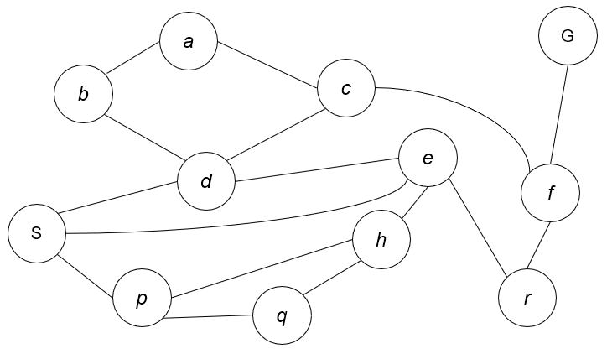
The undirected, unweighted graph G1
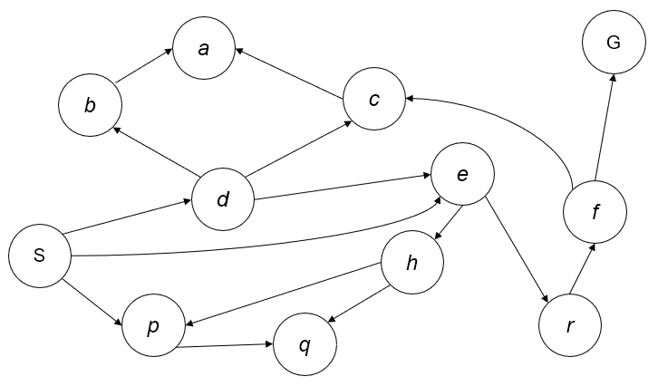
The directed unweighted graph G2

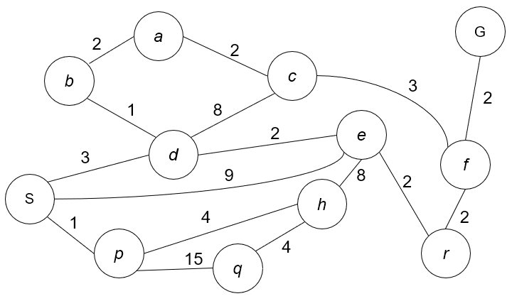
The undirected, weighted graph G3
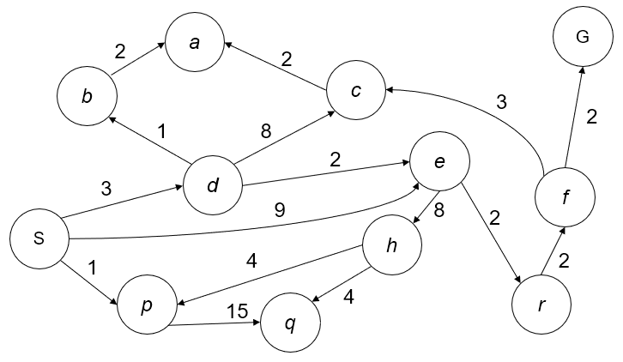
The directed, weighted graph G4

Given a graph with starting vertex S,
where the graph can be directed or undirected,
(We will do both -- see graphs G1 and G2 below), implement BFS and DFS using both the 1) recursion, and 2) stack implementations,
and compare how the execution are performed in the steps and if their outcomes are indeed the same.

The graph can be represented as either:
1) vertex-list form, for example
graph = {'A': ['B', 'C'],
'B': ['C', 'D'],
'C': ['D'],
'D': ['C'],
'E': ['F'],
'F': ['C']}
or 2) an adjacency matrix.

See that the graph G can be either weighted or not.
And note that DFS/BFS is for search on unweighted graphs.
And UCS is for search on weighted graphs.

Refer to the graphs G1 to G4 in the figures.
G1 is an undirected, unweighted graph.
G2 is a directed, unweighted graph.
G3 is an undirected, weighted graph.
G4 is a directed, weighted graph.

Observe that all 4 graphs are planar graphs. The search always starts with the starting vertex ‘S’, and the goal of the search should always be the goal vertex ‘G’, for all 4 graphs.
We define the order of the connecting nodes in the vertex-list such that the list is sorted from min to max, according to the node’s ASCII values. For example, the node ‘S’ should contain a connecting node list of (d, e, p) in G1. For another example, the node ‘e’ should contain (e, h, r, s) in G1, and (h,r) in G2, as G2 is a directed graph.

In this homework, you will perform DFS and BFS in both G1 and G2, using both the recursion and stack implementation. You will compare how they performed in the steps in the code, and you should obtain identical output results.

You will perform UCS in both G3 and G4 using priority queue (PQ) implementation.

You can use the python implementation of Priority Queue
See https://docs.python.org/2/library/heapq.html

With the PQ you can avoid the recursion implementation.

Refer to the attachment 00_Search Algo_Solutions.pdf (from the Berkeley intro AI course website) for a practice of how DFS, BFS, and UCS should output.

For each search, your code should print out both (1) the search state expanded (from Start S to Goal G), and (2) the search path returned (also from Start S to Goal G).

In summary, these are the questions that you should provide answer and code.

P1) Perform DFS and BFS on unweighted graphs G1 and G2.
Given the undirected graph G1 represented as vertex-list:
Perform DFS using recursion. (1pt)
Perform DFS using stack. (1pt)
Perform BFS using queue. (1pt)

Given the undirected graph G1 represented as adjacency matrix:
Perform DFS using recursion. (1pt)
Perform DFS using stack. (1pt)
Perform BFS using queue. (1pt)

Given the directed graph G2 represented as vertex-list:
Perform DFS using recursion. (1pt)
Perform DFS using stack. (1pt)
Perform BFS using queue. (1pt)

Given the directed graph G2 represented as adjacency matrix:
Perform DFS using recursion. (1pt)
Perform DFS using stack. (1pt)
Perform BFS using queue. (1pt)

P2) Perform UCS on weighted graph G3 and G4.
Given the undirected weighted graph G3 represented as vertex-list:
Perform UCS using PQ. (2pt)
Given the undirected graph G3 represented as adjacency matrix:
Perform UCS using PQ. (2pt)

Given the directed weighted graph G4 represented as vertex-list:
Perform UCS using PQ. (2pt)
Given the directed weighted graph G4 represented as adjacency matrix:
Perform UCS using PQ. (2pt)

Note: We explicitly asked you to perform the search on the two graph representations (i.e. vertex-list and adjacency matrix) for you to practice and get familiar with them. You are not expected to just do one solution and convert the other representation using the same code! (Coding on vertex-list and adjacent matrix representations separately.) This is considered TRICKING, so no credit will be given!!

